3.81: a) With no wind, the plane would be 110 km west of the starting point; the wind has blown the plane 10 km west and 20 km south in half an hour, so the wind velocity is 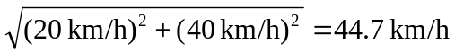 at a direction of 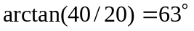 south of west. b) 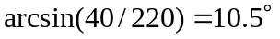 north of west.

